A.1
CREATE DATABASE CollegeDB;
USE CollegeDB;

CREATE TABLE Student (
StudentID INT PRIMARY KEY,
StudentName VARCHAR(50),
Age INT,
Course VARCHAR(30),
City VARCHAR(30),
Marks INT
);

INSERT INTO Student (StudentID, StudentName, Age, Course, City, Marks) VALUES
(1, 'Alice', 20, 'BSc', 'Mumbai', 85),
(2, 'Bob', 21, 'BCA', 'Pune', 78),
(3, 'Charlie', 19, 'BSc', 'Delhi', 92),
(4, 'Diana', 22, 'MCA', 'Mumbai', 88),
(5, 'Eve', 20, 'BCA', 'Nashik', 74),
(6, 'Frank', 21, 'BSc', 'Mumbai', 65),
(7, 'Grace', 19, 'MCA', 'Pune', 95),
(8, 'Heidi', 22, 'BCA', 'Delhi', 81),
(9, 'Ivan', 20, 'BSc', 'Mumbai', 89),
(10, 'Judy', 21, 'MCA', 'Nashik', 76);
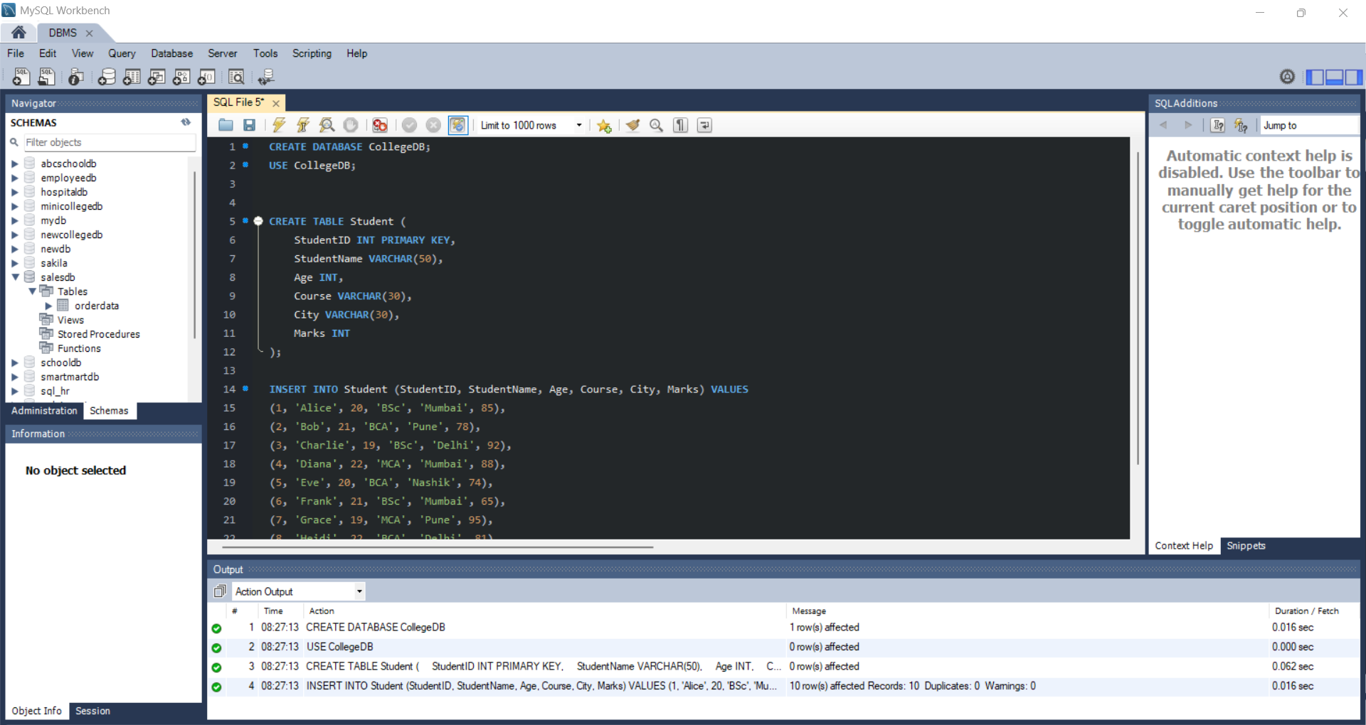

A.2
SELECT * FROM student;
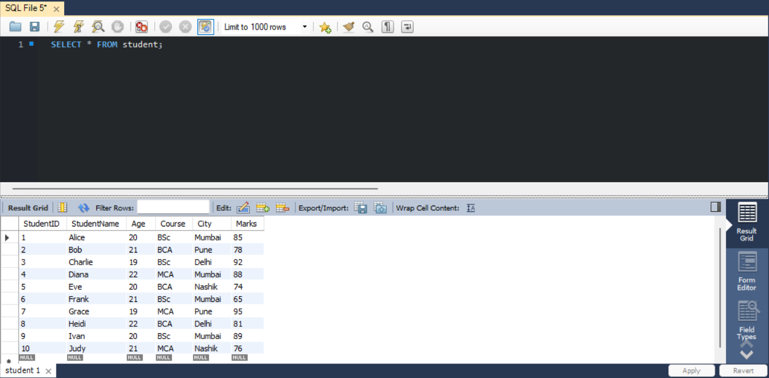

A.3
SELECT StudentName, Course, City FROM student;
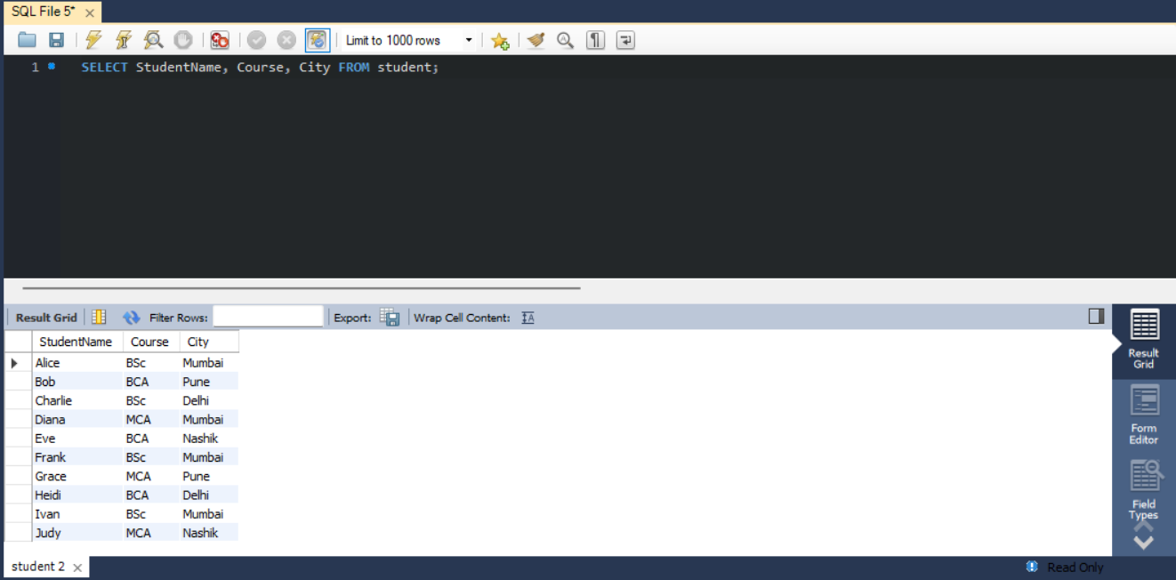

A.4
SELECT StudentID, StudentName, City, Marks FROM student WHERE City = 'Mumbai';
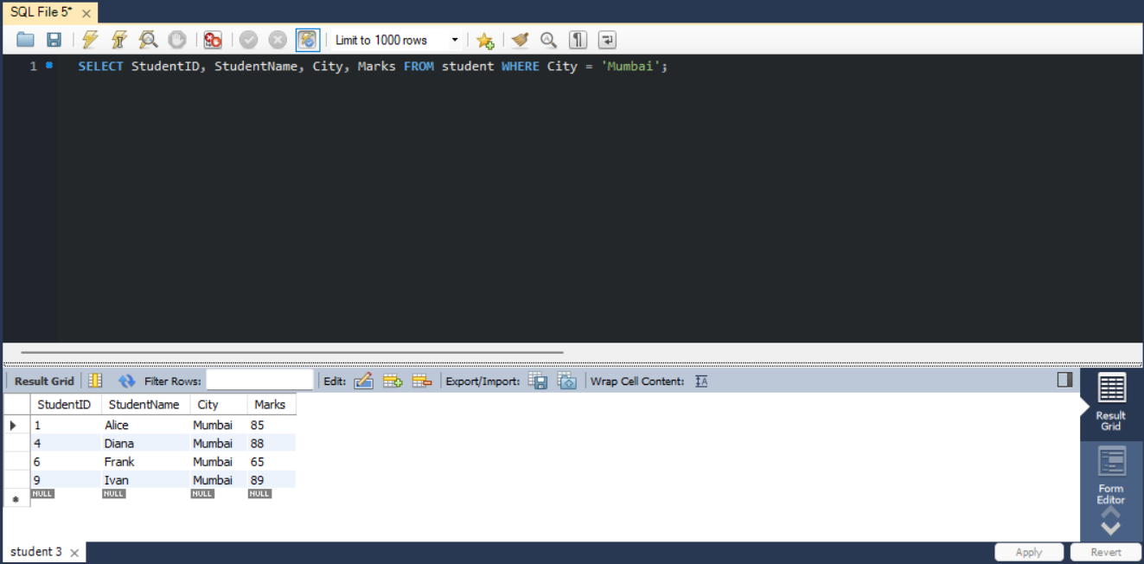

A.5
SELECT * FROM student
WHERE Marks > 80
ORDER BY Marks DESC;
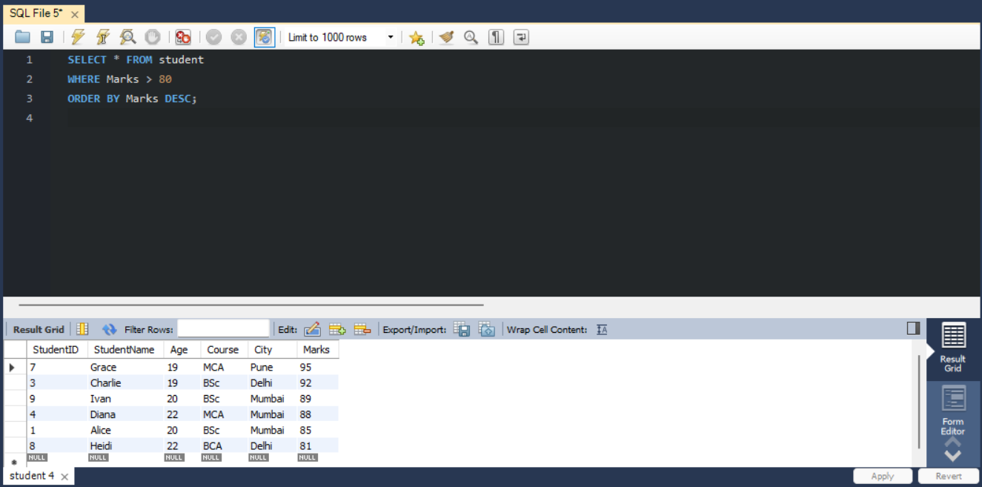

A.6
SELECT StudentName,Marks FROM student
ORDER by Marks DESC
LIMIT 3;
